Attachment 2.1 Ecosystem and Socioeconomic Profile of the Pacific cod stock in the Gulf of Alaska - Report Card

S. Kalei Shotwell, Pete Hulson, Bridget Ferriss, Ben Laurel, and Lauren Rogers

November 2022

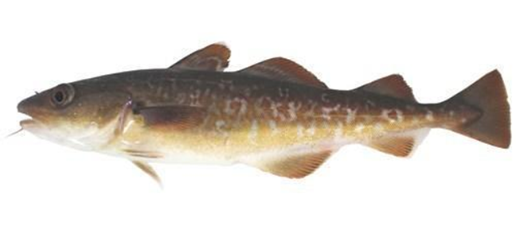

*With Contributions from:*

Kerim Aydin, Steven Barbeaux, Matt Callahan, Wei Cheng, Curry Cunningham, Kirstin Holsman, Sandi Neidetcher, Krista Oke, Patrick Ressler, Heather Renner, Sean Rohan, Elizabeth Siddon, Ingrid Spies, Katie Sweeney, Grant Thompson, Abigail Tyrell, Muyin Wang, Sarah Wise, Stephani Zador

# Current Year Update

The ecosystem and socioeconomic profile or ESP is a standardized framework for compiling and evaluating relevant stock-specific ecosystem and socioeconomic indicators and communicating linkages and potential drivers of the stock within the stock assessment process (Shotwell et al., *In Review*). The ESP process creates a traceable pathway from the initial development of indicators to management advice and serves as an on-ramp for developing ecosystem-linked stock assessments.

Please refer to the last full ESP for further information regarding the ecosystem and socioeconomic linkages for this stock (Shotwell et al., 2021, available online within the Gulf of Alaska (GOA) Pacific cod stock assessment and fishery evaluation report of [Barbeaux et al., 2021](https://apps-afsc.fisheries.noaa.gov/refm/docs/2021/GOApcod.pdf), Appendix 2.1, pp. 161-226).

## Management Considerations

The following are the summary considerations from current year updates to the ecosystem and socioeconomic indicators evaluated for GOA Pacific cod:

* Bottom temperature increased at depth to above average in 2022 but habitat suitability improved suggesting that bottom temperatures are within suitability range for Pacific cod
* Annual eddy kinetic energy has shifted back to a lower energy system similar to 2016 to 2019 suggesting below average larval retention within mesoscale eddies
* Spring bloom timing is near average and high reproductive success of seabirds suggest sufficient forage fish prey resources
* There were few updates for upper trophic indicators as this is an off-cycle survey year but recent biomass estimates of arrowtooth flounder from the stock assessment remain low suggesting less competition or predation on juvenile Pacific cod
* Ex-vessel value remains low, price per pound is stable and near average, but revenue-per-unit-effort has increase to just below average
* Overall, physical indicators were average, and lower trophic indicators were above average in 2022, upper trophic indicators were above average and socioeconomic indicators were below average in 2021. It should be noted that fewer indicators were update this year due to this being an off-cycle survey year.

## Modeling Considerations

The following are the summary results from the intermediate and advanced stage monitoring analyses for GOA Pacific cod:

* Highest ranked predictors for the recruitment importance model were spawning habitat suitability index in the GOA, summer bottom temperature in the GOA, annual Steller sea lion adult counts, and annual arrowtooth biomass in the GOA (inclusion probability > 0.5)
* New research models are being evaluated as alternatives for the operational assessment using indicators of temperature, habitat suitability, and nearshore surveys of age-0 Pacific cod

# 

# Assessment

## Ecosystem and Socioeconomic Processes

Figure 2.1.1 provides a life history conceptual model for GOA Pacific cod that summarizes ecological information and key ecosystem processes affecting survival by life stage. Pacific cod release all their eggs near the bottom in a single event during the late winter/ early spring period in the Gulf of Alaska (Stark, 2007). Unlike most cod species, Pacific cod eggs are negatively buoyant and are semi-adhesive to the ocean bottom substrate during development (Alderdice and Forrester 1971, Ormseth and Norcross, 2009). Hatch timing/success is highly temperature-dependent (Laurel et al., 2008), with optimal hatch occurring in waters ranging between 4-6°C (Bian et al., 2016; Laurel and Rogers 2020) over a broad range of salinities (Alderdice and Forrester 1971). Eggs hatch into 4 mm larvae in ~2 weeks at 5°C (Laurel et al., 2008) and become surface oriented and available to pelagic ichthyoplankton nets during the spring (Doyle and Mier 2016). During this period, Pacific cod larvae are feeding principally on eggs, nauplii and early copepodite stages of copepod prey <300 um (Strasburger et al., 2014). Warm surface waters can accelerate larval growth when prey are abundant (Hurst et al. 2010), but field observations indicate a negative correlation between temperature and abundance of Pacific cod larvae in the Central and Western Gulf of Alaska (Doyle et al., 2009, Doyle and Mier 2016). Laboratory studies suggest warm temperatures can also indirectly impact Pacific cod larvae by way of two mechanisms: 1) increased susceptibility to starvation when the timing and biomass of prey is ‘mis-matched’ under warm spring conditions (Laurel et al., 2011), and 2) reduced growth by way of changes in the lipid/fatty acid composition of the zooplankton assemblage (Copeman and Laurel 2010). The spatial-temporal distribution of Pacific cod larvae shifts with ontogeny and is dependent on a number of behavioral and oceanographic processes. In early April, Pacific cod larvae are most abundant around Kodiak Island before concentrations shift downstream to the SW in the Shumagin Islands in May and June (Doyle and Mier 2016). Newly hatched larvae are surface oriented and make extended diel vertical migrations with increased size and development (Hurst et al. 2009). Larvae reach a developmental milestone (‘flexion’) between 10-15 mm and gradually become more competent swimmers with increasing size (Voesenek et al., 2018). Very late stage larvae (‘pelagic juveniles’) eventually settle to the bottom in early summer around 30-40 mm and use nearshore nurseries through the summer and early fall in the Gulf of Alaska (Laurel et al., 2017). Cross-shelf transport may be an important process for assisting larvae and early juveniles to the nearshore nurseries for settlement. Sustained along shore currents may sweep eggs and larvae from the system before they can settle to the bottom as juveniles (Hinckley et al., 2019). Mesoscale oceanographic features such as eddies or gap winds may assist in entraining eggs and larvae in the system to allow time for growth to a large enough size to settle in preferred nearshore habitat (Sinclair and Crawford, 2005).

Shallow, coastal nursery areas provide age-0 juvenile Pacific cod ideal conditions for rapid growth and refuge from predators (Laurel et al., 2007). A fairly narrow and shallow depth range for the early juveniles suggesting the importance of these nearshore habitats for GOA Pacific cod. Tidal current also contributes to the spatial distribution in the early juvenile stage suggesting some influence of transport mechanisms in this stage as well. Settled juvenile cod associate with bottom habitats and feed on small calanoid copepods, mysids, and gammarid amphipods during this period (Abookire et al., 2007). At the end of August, age-0 cod become less associated with structural habitats and transition into deeper water in the fall (Laurel et al., 2009). Therefore, first year assessments of Pacific cod in the Gulf of Alaska are better suited during the early larval or later post-settled juvenile period. The summer thermal conditions in the Central/Western GOA have historically been well-suited for high growth and survival potential for juvenile Pacific cod (Laurel et al., 2017), but may have been suboptimal during the 2014-16 marine heatwave (Barbeaux et al., 2020). However, the absence of age-0 fish arriving to nurseries in years with warm springs strongly suggests pre-settlement processes (egg/larval) are determining annual cohort strength in the GOA. Reductions in spawning habitat from subsurface warming appears to be an important mechanism limiting reproductive output in the GOA (Laurel and Rogers 2020), but it is likely one of several mechanisms driving recruitment dynamics. The direct impacts of temperature on life history processes in Pacific cod are stage- and size-dependent but these relationships generally are ‘dome shaped’ like other cod species (e.g., Hurst et al. 2010; Laurel et al. 2016a). Pacific cod are opportunistic predators, eating a variety of zooplankton, crab, and fish species (Aydin et al., 2007). In the absence of abundance estimates of prey resources, the reproductive success of piscivorous and planktivorous seabirds in the GOA can be used to inform prey quality and quantity (e.g., Piatt, 2002). Walleye pollock and halibut account for the greatest sources of predation mortality for Pacific cod in the GOA, followed by sperm whales, Steller sea lions, and dogfish (Aydin et al., 2007).

Pacific cod has been a critical species in the catch portfolio of the GOA fisheries (Fissel et al., 2019). The Pacific cod total allowable catch (TAC) is allocated to multiple sectors. In the GOA, sectors are defined by gear type (hook and line, pot, trawl and jig) and processing capacity (catcher vessel (CV) and catcher processor (CP)). Within the sectoral allocations the fisheries effectively operate as open access with limited entry. The majority of GOA Pacific cod is caught by CVs which make deliveries to shore-based processors and accounts for 90% of the total GOA Pacific cod catch. Approximately 25% is caught by the trawl, 55% is caught by pot gear, and 20% caught by hook and line, though the number of hook and line vessels is far greater. Harvests from catcher vessels that deliver to shoreside processors account for approximately 90% of the retained catch. Catch from the fixed gear vessels (which includes hook-and-line and pot gear) typically receive a slightly higher price from processors because they incur less damage when caught. The two primary product forms produced from cod in the GOA are fillets and head and gut (H&G) and the relative share can fluctuate year over year depending on relative prices and processing decisions. U.S. exports of cod are roughly proportional to U.S. cod production. More than 90% of the exports are H&G, much of which goes to China for secondary processing and re-export. The cod industry has largely avoided U.S. tariffs that would have a significant negative impact on them in the U.S.-China trade war. However, Chinese tariffs on U.S. products could be inhibiting growth in that market and putting downward pressure on Pacific cod export prices. Japan and Europe (mostly Germany and the Netherlands) are also important export destinations. Japan and Europe accounted for 12% and 22% of the export volume respectively. Approximately 35% of Alaska’s cod production is estimated to remain in the U.S. Because U.S. cod production is approximately 15% of global production and the GOA is approximately 6% of U.S. production, the GOA Pacific cod is a relatively small component of the broader cod market. A portion of the Russian catch of Pacific cod became MSC certified in Oct. 2019 which could put further downward pressure on prices going forward.

An analysis of commercial processing and harvesting data may be conducted to examine sustained participation for those communities substantially engaged in a commercial fishery. The Annual Community Engagement and Participation Overview (ACEPO) is a new report that evaluates engagement at the community level and focuses on providing an overview of harvesting and processing sectors of identified highly engaged communities for groundfish and crab fisheries in Alaska (Wise et al., 2021). Within the processing sector four ports emerged as highly engaged: Akutan, King Cove, Kodiak, and Sand Point. In the last five years, Kodiak accounted for an average of 47% of GOA Pacific cod landings revenue, with Sand Point, King Cove, and Akutan combined landed 53% (Wise et al., 2021). Within the GOA Pacific cod harvesting sector, four communities emerged as highly engaged: Kodiak and Sand Point again, Homer, and Seattle MSA (metropolitan statistical area). Kodiak has historically had the highest harvest engagement, bringing in an average of 50% of all the GOA Pacific cod harvested since 2015. The number of vessels participating in the GOA Pacific cod fishery decreased across highly engaged communities by 70% since 2000. These decreases depict an overall decline in sustained participation (Wise et al., 2021).

## Indicator Suite

The following list of indicators for GOA Pacific cod are organized by categories, three for ecosystem indicators (physical, lower trophic, and upper trophic) and three for socioeconomic indicators (fishery performance, economic, and community). A short description and contact name for the indicator contributor are provided. For ecosystem indicators, we also include the anticipated sign of the proposed relationship between the indicator and the stock population dynamics where relevant. Please refer to the full ESP document for detailed information regarding the ecosystem and socioeconomic indicator descriptions and proposed mechanistic linkages for this stock (Shotwell et al., 2021). Time series of the ecosystem and socioeconomic indicators are provided in Figure 2.1.2a and Figure 2.1.2b, respectively.

### Ecosystem Indicators:

Physical Indicators (Figure 2.1.2a.a-d)

* 1. Spawning marine heatwave cumulative index over the central GOA (contact: S. Barbeaux). Proposed sign of relationship is negative.
  2. Winter spring spawning habitat suitability index from January to April in the central GOA shelf at GAK1 station (contact: L. Rogers). Proposed sign of relationship is positive and the time series is not lagged for the intermediate stage indicator analysis.
  3. Summer bottom temperatures where small Pacific cod (0-20 cm) have been sampled by the AFSC GOA bottom trawl survey from the CFSR dataset (contact: M. Wang). Proposed sign of relationship is negative and the time series is not lagged for the intermediate stage indicator analysis.
  4. Annual eddy kinetic energy (EKE) calculated from sea surface height in the Kodiak area (contact: W. Cheng). Proposed sign of relationship is positive and the time series is not lagged for the intermediate stage indicator analysis.

Lower Trophic Indicators (Figure 2.1.2a.e-i)

* 1. Peak timing of the spring bloom averaged across individual ADF&G statistical areas in the western and central GOA region from the MODIS satellite (contact: M. Callahan). Proposed sign of relationship is positive.
  2. Summer large copepods for young-of-the-year (YOY) from the EcoFOCI summer survey (contact: L. Rogers). Proposed sign of relationship is positive.
  3. Summer euphausiid abundance for the Gulf of Alaska from the AFSC acoustic survey (contact: P. Ressler). Proposed sign of relationship is positive.
  4. Spring Pacific cod larvae catch-per-unit-of-effort (CPUE) from the EcoFOCI spring survey (contact: L. Rogers). Proposed sign of relationship is positive.
  5. Common murre (piscivores) reproductive success at Chowiet Island (contact: S. Zador). Proposed sign of relationship is positive.

Upper Trophic Indicators (Figure 2.1.2a.j-o)

* 1. Summer condition for juvenile (<420 mm) Pacific cod from the AFSC GOA shelf bottom trawl survey (contact: S. Rohan). Proposed sign of relationship is positive.
  2. Summer condition for adult (>=420 mm) Pacific cod from the AFSC GOA shelf bottom trawl survey (contact: S. Rohan). Proposed sign of relationship is positive.
  3. Summer Pacific cod center of gravity northeastings estimated by a spatio-temporal model using the package VAST on AFSC GOA bottom trawl survey data (contact: Z. Oyafuso). Proposed sign of relationship is negative.
  4. Summer Pacific cod area occupied estimated by a spatio-temporal model using the package VAST on AFSC GOA bottom trawl survey data (contact: Z. Oyafuso)
  5. Arrowtooth flounder total biomass from the most recent stock assessment model in the GOA (contact: K. Shotwell). Proposed sign of relationship is negative and the time series is lagged two years for the intermediate stage indicator analysis.
  6. Steller sea lion non-pup estimates for the GOA portion of the western Distinct Population Segment (contact: K. Sweeney). Proposed sign of relationship is negative and the time series is lagged two years for the intermediate stage indicator analysis.

### Socioeconomic Indicators:

Economic Indicators (Figure 2.1.2b.a-c)

* 1. Annual estimated real ex-vessel value of GOA Pacific cod (contact: J. Lee)
  2. Annual real ex-vessel price per pound of GOA Pacific cod from fish ticket information (contact: J. Lee).
  3. Annual estimated real revenue per unit effort measured in weeks fished of GOA Pacific cod (contact: J. Lee)

Community Indicators (Figure 2.1.2b.d-g)

* 1. Regional quotient of Pacific cod for harvesting revenue of the highly engaged community of Kodiak (contact: S. Wise)
  2. Regional quotient of Pacific cod for processing revenue of the highly engaged community of Kodiak (contact: S. Wise)
  3. Regional quotient of Pacific cod for harvesting revenue of three smaller highly engaged communities (Sand Point, King Cove, and Akutan) combined (contact: S. Wise)
  4. Regional quotient of Pacific cod for processing revenue of three smaller highly engaged communities (Sand Point, King Cove, and Akutan) combined (contact: S. Wise)

## Indicator Monitoring Analysis

There are up to three stages (beginning, intermediate, and advanced) of statistical analyses for monitoring the indicator suite listed in the previous section. The beginning stage is a relatively simple evaluation by traffic light scoring. This evaluates the current year trends relative to the mean of the whole time series, and provides a historical perspective on the utility of the whole indicator suite. The intermediate stage uses importance methods related to a stock assessment variable of interest (e.g., recruitment, biomass, catchability). These regression techniques provide a simple predictive performance for the variable of interest and are run separate from the stock assessment model. They provide the direction, magnitude, uncertainty of the effect, and an estimate of inclusion probability. The advanced stage is used for testing a research ecosystem linked model and output can be compared with the current operational model to understand information on retrospective patterns, prediction performance, and comparisons of other model output such as terminal spawning stock biomass or mean recruitment. This stage provides an on-ramp for introducing an alternative ecosystem linked stock assessment model to the current operational stock assessment model and can be used to understand the potential reduction in uncertainty by including the ecosystem information. Please refer to the indicator monitoring analysis section in the main text of this appendix for more details on the analysis stages.

### Beginning Stage: Traffic Light Test

We use a simple scoring calculation for this beginning stage traffic light evaluation. Indicator status is evaluated based on being greater than ("high"), less than ("low"), or within ("neutral") one standard deviation of the long-term mean. A sign based on the anticipated relationship between the indicator and the stock (generally shown in Figure 2.1.1 and specifically by indicator in the Indicator Suite, Ecosystem Indicators section) is also assigned to the indicator where possible. If a high value of an indicator generates good conditions for the stock and is also greater than one standard deviation above the mean, then that value receives a "+1" score. If a high value generates poor conditions for the stock and is greater than one standard deviation above the mean, then that value receives a "-1" score. All values less than or equal to one standard deviation from the long-term mean are average and receive a "0" score. The scores are summed by the three organizational categories within the ecosystem (physical, lower trophic, and upper trophic) or socioeconomic (fishery performance, economic, and community) indicators and divided by the total number of indicators available in that category for a given year. The scores over time allow for comparison of the indicator performance and the history of stock productivity (Figure 2.1.3). We also provide five year indicator status tables with a color or text code for the relationship with the stock (Tables 2.1.2a,b) and evaluate the current year status in the historical indicator time series graphic (Figures 2.1.2a,b) for each ecosystem and socioeconomic indicator.

We evaluate the status and trends of the ecosystem and socioeconomic indicators to understand the pressures on the GOA Pacific cod stock regarding recruitment, stock productivity, and stock health. We start with the physical indicators and proceed through the increasing trophic levels, economic, and community indicators as listed above. Here we concentrate on updates relative to the results presented in the last full ESP (Shotwell et al., 2021). Overall both the physical indicators scored average and the lower trophic indicators scored average for 2022 (Figure 2.1.3). Compared to last year’s results, this is the same for the physical indicators and an improvement for the lower trophic indicators. Two upper trophic indicators were updated for 2021 as the data are always lagged one year due to the timing of the stock assessment review and the marine mammal survey data review. The upper trophic indicators for 2021 were above average. We also note caution when comparing scores between odd to even years as there are many lower and upper trophic indicators missing in even years due to the off-cycle year surveys in the GOA. Also, there have been other cancellations due to COVID-19 or other survey delays in 2020 through 2022 that have limited production of several indicators. Economic and community indicators are all lagged by at least one year due to timing of the availability of the current year information and the production of this report. Economic indicators improved from last year but were still below average for 2021. There were no updates for community indicators.

For physical indicators, there has been increased sea surface warming and reduced Pacific cod spawning habitat suitability in the GOA ecosystem and the presence of a series of major marine heatwaves for the past several years (Figure 2.1.2a.a-c). However, from 2020 through 2021 there were reduced temperatures at the bottom and reduced annual marine heatwave events from the previous warm stanza. In 2022, the bottom temperatures increased again to above average, but the spawning habitat suitability also increased suggesting that the bottom temperature warming was still within suitable ranges for Pacific cod. We also see a shift in the annual eddy kinetic energy (EKE) near Kodiak from average to a lower energy period similar to 2016 to 2019 (Figure 2.1.2a.d). This EKE region near Kodiak has an opposite seasonal cycle phase than other regions in the GOA implying separate forcing mechanisms in the western GOA (Cheng, 2021). Sustained EKE may help with retention on the shelf and enhance cross-shelf transport of young-of-the-year Pacific cod to suitable nearshore nursery environments.

For the lower trophic level indicators (Figure 2.1.2a.e-i), the peak timing of the spring bloom appears highly variable since the onset of the marine heatwaves in 2014 and is now near average. This may have implications for mismatch between larval Pacific cod and the available plankton abundance. During warm years this may be particularly important for Pacific cod due to their increased metabolic requirements and the implications of a later bloom may be somewhat tempered in a cooler thermal environment such as in 2020 and 2021 (B. Laurel, pers. commun.). There were no updates for large copepods, euphausiid abundance, or CPUE of larvae in the spring EcoFOCI survey. Reproductive success of common Murre seabirds on Chowiet is now above one standard deviation of the time series mean suggesting sufficient forage fish prey resources (Figure 2.1.2a.i). The summer nearshore survey in Kodiak also increased to above one standard deviation of the time series mean suggesting good survival of the pelagic early life history phase of the 2022 year class (Figure 2.1.2a.j).

For the upper trophic indicators, there were no updates for the condition, center of gravity or area occupied indicators as this is an off-cycle survey year (Figure 2.1.2a.k-n). The 2021 biomass estimates of the most recent stock assessment for arrowtooth flounder biomass remain low (Shotwell et al., 2021) and predicted counts of Steller sea lions decreased to slightly below average (Figure 2.1.2a.o-p).

For economic indicators (Figure 2.1.2b.a-c), ex-vessel value in 2021 remains below one standard deviation of the time series mean and has been low since 2018 (Figure 2.1.2b.a). Price per pound remains stable but revenue per unit effort increased to just below average in 2021 (Figure 2.1.2b.b-c). Since 2016 reductions in global supply have put upward pressure on prices resulting in significant year over year price increases in 2017 and 2018. In 2019 prices leveled off, decreasing slightly, as markets have adjusted. In 2020 COVID-19 closures resulted in increased demand for retail products and frozen products, and decreased food service and fresh products. Retail and food service are both significant components of the market for cod products. As such, the impact of COVID-19 on prices appears muted with only marginal changes in first-wholesale and export prices. Cost pressure from COVID-19 mitigation efforts likely had upstream impacts on ex-vessel prices, which decreased significantly.

The community indicators evaluated in the ESP are similar to those presented in the ACEPO report but on the stock level rather than the community level. The indicators are separated into two categories of fisheries involvement: commercial processing and commercial harvesting (Wise et al., 2021). By separating commercial processing from commercial harvesting, the engagement indices highlight the importance of fisheries in communities that may not have a large amount of landings or processing in their community, but have a large number of fishers and/or vessel owners that participate in commercial fisheries who are based in the community. At this time there are no updates to the community indicators. In the future we plan to evaluate how to reference the products available in the ACEPO report for use in the ESPs to inform on stock health.

### Intermediate Stage: Importance Test

Bayesian adaptive sampling (BAS) was used for the intermediate stage statistical test to quantify the association between hypothesized predictors and GOA Pacific cod recruitment and to assess the strength of support for each hypothesis. In this stage, the full set of indicators is first winnowed to the predictors that could directly relate to recruitment and highly correlated covariates are removed. We further restrict potential covariates to those that can provide the longest model run and through the most recent estimate of recruitment that is well estimated in the current operational stock assessment model (Figure 2.1.4a). This results in a model run from 1994 through the 2018 year-class. We then provide the mean relationship between each predictor variable and log GOA Pacific cod recruitment over time (Figure 2.1.4b, left side), with error bars describing the uncertainty (95% confidence intervals) in each estimated effect and the marginal inclusion probabilities for each predictor variable (Figure 2.1.4b, right side). A higher probability indicates that the variable is a better candidate predictor of GOA Pacific cod recruitment. The highest ranked predictor variables (inclusion probability > 0.5) based on this process continue to be the spawning habitat suitability index in the GOA and now the summer bottom temperature in the GOA, the annual Steller sea lion adult counts, and the annual arrowtooth biomass in the GOA (Figure 2.1.4).

### Advanced Stage: Research Model Test

Further development continued in 2021 on the ecosystem research models (Barbeaux et al. 2021) that incorporated links for catchability, mortality, growth, and recruitment using CFSR predicted bottom temperatures, NOAA reanalysis predicted surface temperatures, and heatwave indices. These ecosystem linked models were presented at the same time as the operational stock assessment model but were not considered for use in tactical management of the stock at this time. However, projections based on CMIP 5 were provided to the end of the century for strategic considerations and evaluating the performance of the current control rules. At this time these models are being further developed and could be presented as alternatives in future stock assessment model evaluations.

In the future, mortality switches could be evaluated in the advanced stage statistical test, which is a modeling application that analyzes predictor performance and estimates risk probabilities within the operational stock assessment model. Output of two new model developments could be used to generate or enhance an ecosystem-linked model for GOA Pacific cod. First, a new multi-species statistical catch-at-age assessment model (known as CEATTLE; Climate- Enhanced, Age-based model with Temperature-specific Trophic Linkages and Energetics; Holsman et al., 2016) has recently been developed for understanding trends in age-1 total mortality for Pacific cod, walleye pollock, and arrowtooth flounder from the GOA (Adams et al., 2022). Total mortality rates are based on residual mortality inputs (M1), model estimates of annual predation mortality (M2), and fishing mortality (F). CEATTLE has been modified for the GOA and implemented in Template Model Builder (Kristensen et al., 2015) to allow for the fitting of multiple sources of data, time-varying selectivity, time-varying catchability, and random effects. The model is based, in part, on the parameterization and data used for the most recent stock assessment model of each species (Barbeaux et al., 2021, Dorn et al., 2021, and Shotwell et al., 2021). The model is fit to data from five fisheries and seven surveys, including both age and length composition assumed to come from a multinomial distribution. Model estimates of M2 are empirically driven by bioenergetics-based consumption information and diet data from the GOA to inform predator-prey suitability. The model was fit to data from 1977 to present.

A spatially-explicit individual-based model (IBM) for the early life stages of Pacific cod was developed as part of the GOA Integrated Ecosystem Research Program (GOAIERP) (Hinckley et al., 2019) using the DisMELS (Dispersal Model for Early Life Stages) IBM framework. It has since been updated to include temperature-dependent egg development and a better characterization of juvenile nursery habitat based on a Habitat Suitability Model. The IBM tracks the 3-dimensional location, growth, and other characteristics of simulated individuals from the egg stage to the benthic juvenile stage using stored 4-dimensional (3-d space and time) ROMS model output to provide the spatiotemporally-varying environment (e.g., 3-dimensional temperature, NPZ, and current fields) in which the individuals "exist". Egg development and larval/juvenile growth rates depend on *in situ* temperature. Vertical movement in the water column is also stage-specific, but horizontal dispersion is currently assumed to be passive. Individual location and other characteristics are updated using Lagrangian particle tracking with a 20-minute integration time step. It would be possible to derive several types of indices using the IBM and ROMS model output for the current year, including: 1) changes in connectivity between presumed spawning and juvenile nursery habitats; 2) spatiotemporally-averaged, temperature-dependent egg development success; and 3) life stage-specific, spatiotemporally-averaged, temperature-dependent growth rates. Once the ROMS model output is available, it takes several hours on a laptop to run the IBM for a year simulating ~100,000 individuals. Additional time would be required to calculate the desired indices, but turn-around could be reasonably quick.

The age-1 mortality index could provide a gap free estimate of predation mortality. Indeed, the age-specific mortality estimates from the GOA CEATTLE model are being tested as priors for age-specific mortality within the age-structured model, however fitting age-specific annually varying mortality within the model has proven to be challenging given the lack of data on younger fish (age 0-3) and will require further development. Additionally, the spawning habitat suitability index and the age-0 beach seine index continue to be explored for use in the most recent age-structured model as an age-0 index. Potentially in the future, other high importance indicators from the Intermediate Stage analysis could also be used directly to help explain the variability in recruitment deviations and predict pending recruitment events for GOA Pacific cod. The ecosystem indicators could also be used to explore linkages to time-varying growth patterns for GOA Pacific cod.

# Data Gaps and Future Research Priorities

While the metric and indicator assessments provide a relevant set of proxy indicators for evaluation at this time, there are certainly areas for improvement. The majority of indicators collected for GOA Pacific cod have a fair number of gaps due to the biennial nature of survey sampling in the GOA. This causes issues with updating the ESP and the ecosystem considerations during off-cycle years and can lead to difficulty in identifying impending shifts in the ecosystem that may impact the GOA Pacific cod population. Development of high-resolution remote sensing (e.g., regional surface temperature, transport estimates, primary production estimates) or climate model indicators (e.g., bottom temperature, nutrient-phytoplankton-zooplankton variables) would assist with the current multi-year data gap for several indicators if they sufficiently capture the main trends of the survey data and are consistently and reliably available for use.

Refinements or updates to current indicators may also be helpful. More specific phytoplankton indicators tuned to the spatial and temporal distribution of GOA Pacific cod larvae as well as phytoplankton community structure information (e.g., hyperspectral information for size fractionation) could be more useful for understanding Pacific cod larval fluctuations. Current estimates of zooplankton biomass are only available at smaller spatial scales and regional to gulf-wide estimates of zooplankton biomass would help elucidate prey trends at the spatial scales relevant to fisheries management. Demographic differences in the YOY population need to be evaluated within and among larval and juvenile surveys conducted in the Central and Western GOA (currently sampling ~1000km of coastline). Size shifts in the YOY population have already been observed in marine heatwave years, but it is unclear if one or more of the following processes are involved: 1) spawning (earlier); 2) larval/juvenile growth (higher); and/or 3) larval/juvenile mortality (higher/size-selective). Ongoing research seeks to understand how climate-driven changes in size and age may also impact survival trajectories of YOY cohorts and their potential to recruit to the fishery, which will guide further indicator development.

We currently lack an indicator of predation on YOY Pacific cod during their first autumn and winter, during a period when predation mortality is thought to be significant. Sampling of predator diets in fall and winter would help to fill this gap. An index of age-1 Pacific cod from the Kodiak beach seine survey is also available and could be useful for understanding overwinter survival in reference to the age-0 index explored for use in the operational model. The GOA CEATTLE model is now published and has potential to provide a gap-free index of predation mortality for age-1 GOA Pacific cod (Adams et al., 2022). The Pacific cod individual based model (IBM) is also currently being updated (Shotwell et al., *In prep.*) as part of the Essential Fish Habitat (EFH) update. Information on connectivity from spawning to nursery areas and dynamic spatial distribution of egg and larval EFH could be used to create indicators for understanding early life history dynamics. Additionally, evaluating condition and energy density of juvenile and adult Pacific cod samples at the outer edge of the population may be useful for understanding the impacts of shifting spatial statistics such as center of gravity and area occupied. Information is available from the GulfWatch Alaska program that could be helpful for evaluating the eastern edge of the GOA Pacific cod population. Also, a new project has recently been funded involving a multi-model approach including the development of the GOA Ecopath models and an Atlantis ecosystem model. This project is part of the GOA Regional Action Plan and will start in 2021 with the goal of evaluating the biological reference points used for status determination of individual stocks (e.g., Pacific cod) under projected climate scenarios (M. Dorn, *pers., commun*.). The project has a three-year timeline and we hope to incorporate the results of this effort as they become available.

We plan to evaluate the information provided in the Economic SAFE and ACEPO report to determine what socioeconomic indicators could be provided in the ESP that are not redundant with those reports and related directly to stock health. This may result in a transition of indicators currently reported in this ESP to a different series of socioeconomic indicators in future ESPs and may include a shift in focus from engagement to dependency. Additional considerations should be given for the timing of the economic and community reports that are delayed by 1-2 years depending on the data source from the annual stock assessment cycle. The Scientific and Statistical Committee (SSC) recently recommended that local knowledge, traditional knowledge and subsistence information may be helpful for understanding recent fluctuations in stock health, shifts in stock distributions, or changes in size or condition of species in the fishery. We could include this information as supportive evidence and perspective on many indicators monitored within the ESP.

As indicators are improved or updated, they may replace those in the current set of indicators to allow for refinement of the BAS model and potential evaluation of performance and risk within the operational stock assessment model. Incorporating additional importance methods in the intermediate stage indicator analysis may also be useful for evaluating the full suite of indicators and may allow for identifying robust indicators for potential use in the operational stock assessment model. The annual request for indicators (RFI) for the GOA Pacific cod ESP will include these data gaps and research priorities along with a list of potential new indicators that could be developed for the next full ESP assessment.

# Literature Cited

Adams, G.D., K.K. Holsman, S.J. Barbeaux, M.W. Dorn, J.N. Ianelli, I. Spies, I.J. Stewart, and A.E. Punt. 2022. An ensemble approach to understand predation mortality for groundfish in the Gulf of Alaska. Fish. Res. 251, 106303. <https://doi.org/10.1016/j.fishres.2022.106303>.

Cheng, W. 2021. Eddies in the Gulf of Alaska. *In* Ferriss, B., and Zador, S., 2021. Ecosystem Status Report 2021: Gulf of Alaska, Stock Assessment and Fishery Evaluation Report, North Pacific Fishery Management Council, 1007 West Third, Suite 400, Anchorage, Alaska 99501.

Deary, A., L. Rogers, and K. Axler. 2021. Larval fish abundance in the Gulf of Alaska 1981-2021. *In* Ferriss, B., and Zador, S., 2021. Ecosystem Status Report 2021: Gulf of Alaska, Stock Assessment and Fishery Evaluation Report, North Pacific Fishery Management Council, 1007 West Third, Suite 400, Anchorage, Alaska 99501.

Fissel, B., M. Dalton, B. Garber-Yonts, A. Haynie, S. Kasperski, J. Lee, D. Lew, C. Seung, K. Sparks, M. Szymkowiak, and S. Wise. 2021. Economic status of the groundfish fisheries off Alaska, 2019. *In* Stock assessment and fishery evaluation report for the groundfish resources of the GOA and BS/AI. North Pacific Fishery Management Council, 605 W 4th Ave, Suite 306 Anchorage, AK 99501.

O'Leary, C., Laman, N., Rohan, S. 2021. Gulf of Alaska groundfish condition. *In* Ferriss, B., and Zador, S., 2021. Ecosystem Status Report 2021: Gulf of Alaska, Stock Assessment and Fishery Evaluation Report, North Pacific Fishery Management Council, 605 W 4th Ave, Suite 306, Anchorage, AK 99501.

Shotwell, S.K., K., Blackhart, C. Cunningham, E. Fedewa, D., Hanselman, K., Aydin, M., Doyle, B., Fissel, P., Lynch, O. Ormseth, P., Spencer, S., Zador. *In Review*. Introducing the Ecosystem and Socioeconomic Profile, a proving ground for next generation stock assessments.

Shotwell, S.K., S. Barbeaux, B. Ferriss, B. Fissel, B. Laurel, B. Matta, L. Rogers, E. Siddon and A. Tyrell. 2021. Ecosystem and socioeconomic profile of the Pacific cod stock in the Gulf of Alaska. Appendix 2.1 In Barbeaux, S., B. Ferriss, B. Laurel, M. Litzow, S. McDermott, J. Nielsen, W. Palsson, K. Shotwell, I. Spies, and M. Wang. 2021. Assessment of the Pacific cod stock in the Gulf of Alaska. Stock assessment and fishery evaluation report for the groundfish resources of the Gulf of Alaska. North Pacific Fishery Management Council, 1007 W 3rd Ave, Suite 400 Anchorage, AK 99501. Pp. 161-226.

Shotwell, K., I. Spies, J.N. Ianelli, K. Aydin, D.H Hanselman, W. Palsson, K. Siwicke, and E. Yasumiishi. 2021. Assessment of the arrowtooth flounder stock in the Gulf of Alaska. *In* Stock assessment and fishery evaluation report for the groundfish resources of the Gulf of Alaska. North Pacific Fishery Mngt. Council, 605 W 4th Ave, Suite 306 Anchorage, AK 99501.

Shotwell, S.K., W. Stockhausen, G.A. Gibson, J. Pirtle, A. Deary, and C. Rooper. In Prep. Developing a novel approach to estimate habitat-related survival rates for early life history stages using individual-based models.

Whitehouse, A. and K. Aydin. 2021. Foraging guild biomass-Gulf of Alaska. *In* Ferriss, B. and Zador, S., 2021. Ecosystem Status Report 2021: Gulf of Alaska, Stock Assessment and Fishery Evaluation Report, North Pacific Fishery Management Council, 1007 West Third, Suite 400, Anchorage, Alaska 99501.

Wise, S., K. Sparks, and J. Lee. 2021. Annual Community Engagement and Participation Overview. Report from the Economic and Social Sciences Program of the Alaska Fisheries Science Center. 57 pp.

# 

# Tables

#### Table 2.1.1a. First stage ecosystem indicator analysis for GOA Pacific cod, including indicator title and the indicator status of the last five years. The indicator status is designated with text, (greater than = “high”, less than = “low”, or within 1 standard deviation = “neutral” of long-term mean). Fill color of the cell is based on the sign of the anticipated relationship between the indicator and the stock (blue or italicized text = good conditions for the stock, red or bold text = poor conditions, white = average conditions). A gray fill and text = “NA” will appear if there were no data for that year.

|  |  |  |  |  |  |  |
| --- | --- | --- | --- | --- | --- | --- |
| **Indicator category** | **Indicator** | **2018 Status** | **2019 Status** | **2020 Status** | **2021 Status** | **2022 Status** |
| Physical | Spawning Heatwave GOA Model | neutral | **high** | neutral | neutral | neutral |
| Winter Spring Pacific Cod Spawning Habitat Suitability GAK1 Model | neutral | **low** | neutral | neutral | neutral |
| Summer Temperature Bottom GOA Model | neutral | **high** | neutral | neutral | neutral |
| Annual Eddy Kinetic Energy Kodiak Satellite | neutral | neutral | *high* | neutral | neutral |
| Lower Trophic | Spring Chlorophyll a Peak WCGOA Satellite | **low** | *high* | **low** | neutral | neutral |
| Summer Large Copepod Abundance Shelikof Survey | NA | neutral | NA | NA | NA |
| Summer Euphausiid Abundance Kodiak Survey | NA | neutral | NA | NA | NA |
| Spring Pacific Cod CPUE Larvae Shelikof Survey | NA | neutral | NA | neutral | NA |
| Annual Common Murre Reproductive Success Chowiet Survey | neutral | *high* | NA | neutral | *high* |
| Summer Pacific Cod CPUE YOY Nearshore Kodiak Survey | neutral | neutral | *high* | neutral | *high* |
| Upper Trophic | Summer Pacific Cod Condition Juvenile GOA Survey | NA | neutral | NA | neutral | NA |
| Summer Pacific Cod Condition Adult GOA Survey | NA | neutral | NA | neutral | NA |
| Summer Pacific Cod Center Gravity Northeast WCGOA Model | NA | **high** | NA | neutral | NA |
| Summer Pacific Cod Area Occupied WCGOA Model | NA | *high* | NA | *high* | NA |
| Annual Arrowtooth Biomass GOA Model | neutral | neutral | *low* | *low* | NA |
| Annual Steller Sea Lion Adult GOA Survey | neutral | neutral | neutral | neutral | NA |

#### Table 2.1.1b. First stage socioeconomic indicator analysis for GOA Pacific cod, including indicator title and the indicator status of the last five years. The indicator status is designated with text, (greater than = “high”, less than = “low”, or within 1 standard deviation = “neutral” of long-term mean). A gray fill and text = “NA” will appear if there were no data for that year.

|  |  |  |  |  |  |  |
| --- | --- | --- | --- | --- | --- | --- |
| **Indicator category** | **Indicator** | **2018 Status** | **2019 Status** | **2020 Status** | **2021 Status** | **2022 Status** |
| Economic | Annual Pacific Cod Real Exvessel Value GOA Fishery | low | low | low | low | NA |
| Annual Pacific Cod Real Exvessel Price GOA Fishery | neutral | high | neutral | neutral | NA |
| Annual Pacific Cod Real Revenue Per Unit Effort GOA Fishery | neutral | high | low | neutral | NA |
| Community | Annual Pacific Cod RQ Harvesting Revenue Kodiak Fishery | low | low | NA | NA | NA |
| Annual Pacific Cod RQ Processing Revenue Kodiak Fishery | low | low | NA | NA | NA |
| Annual Pacific Cod RQ Harvesting Revenue Small Communities GOA Fishery | low | low | NA | NA | NA |
| Annual Pacific Cod RQ Processing Revenue Small Communities GOA Fishery | low | low | NA | NA | NA |

# 

# Figures

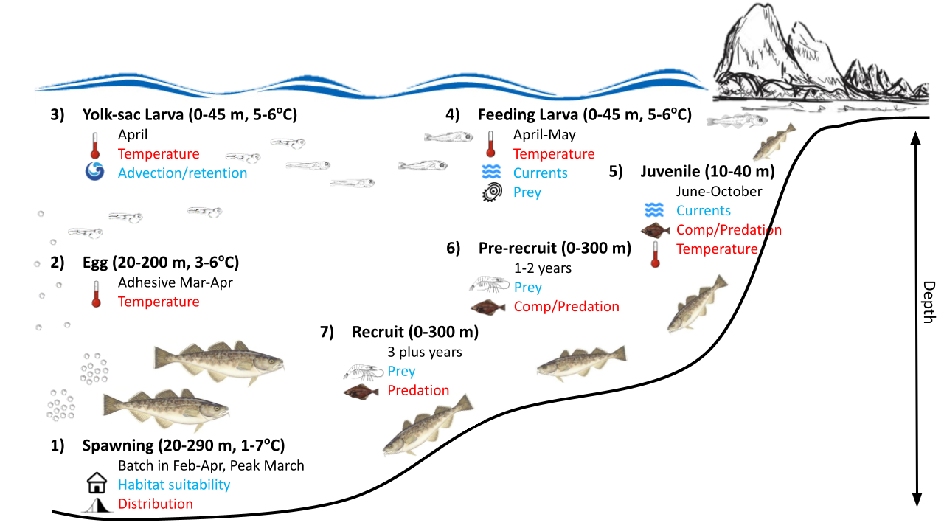

#### Figure 2.1.1: Life history conceptual model for GOA Pacific cod summarizing ecological information and key ecosystem processes affecting survival by life history stage. Red text means increases in the process negatively affect survival, while blue text means increases in the process positively affect survival.

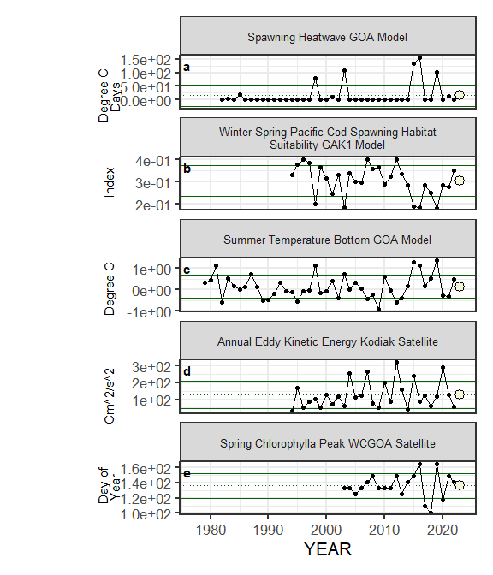

#### Figure 2.1.2a. Selected ecosystem indicators for GOA Pacific cod with time series ranging from 1977 – present. Upper and lower solid green horizontal lines represent 1 standard deviation of the time series mean. Dotted green horizontal line is the mean of the time series. A symbol appears when current year data are available and follows the traffic light status table designations (triangle direction represents if above or below 1 standard deviation of the time series mean, color represents proposed relationship for stock, white circle for neutral).

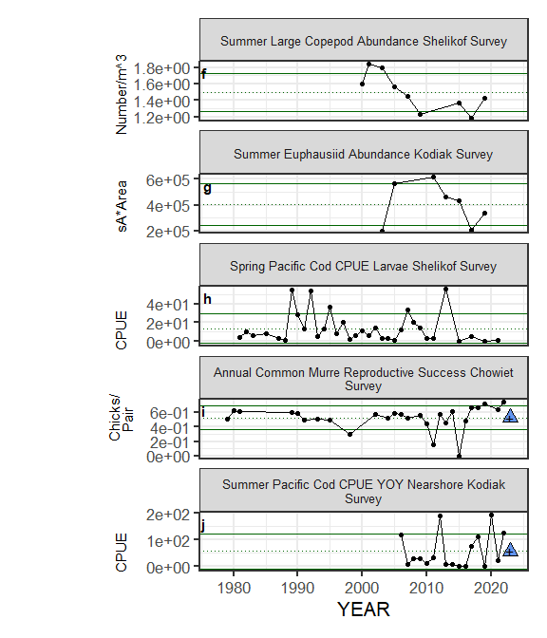

Figure 2.1.2a (cont.). Selected ecosystem indicators for GOA Pacific cod with time series ranging from 1977 – present. Upper and lower solid green horizontal lines represent 1 standard deviation of the time series mean. Dotted green horizontal line is the mean of the time series. A symbol appears when current year data are available and follows the traffic light status table designations (triangle direction represents if above or below 1 standard deviation of the time series mean, color represents proposed relationship for stock, white circle for neutral).

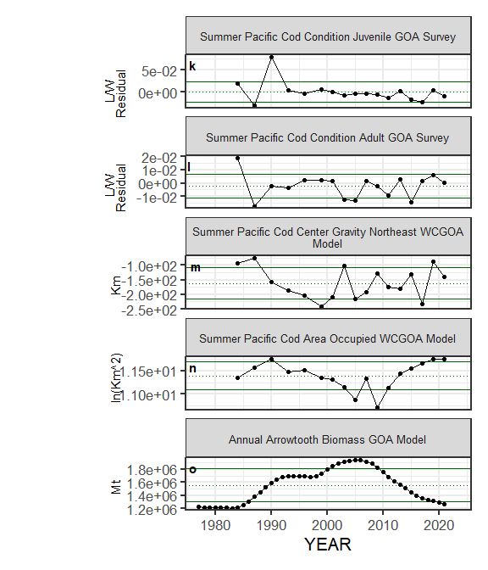

Figure 2.1.2a (cont.). Selected ecosystem indicators for GOA Pacific cod with time series ranging from 1977 – present. Upper and lower solid green horizontal lines represent 1 standard deviation of the time series mean. Dotted green horizontal line is the mean of the time series. A symbol appears when current year data are available and follows the traffic light status table designations (triangle direction represents if above or below 1 standard deviation of the time series mean, color represents proposed relationship for stock, white circle for neutral).

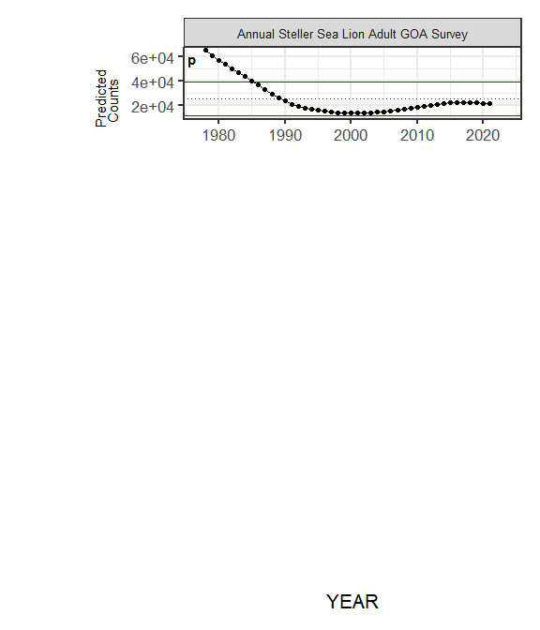

Figure 2.1.2a (cont.). Selected ecosystem indicators for GOA Pacific cod with time series ranging from 1977 – present. Upper and lower solid green horizontal lines represent 1 standard deviation of the time series mean. Dotted green horizontal line is the mean of the time series. A symbol appears when current year data are available and follows the traffic light status table designations (triangle direction represents if above or below 1 standard deviation of the time series mean, color represents proposed relationship for stock, white circle for neutral).

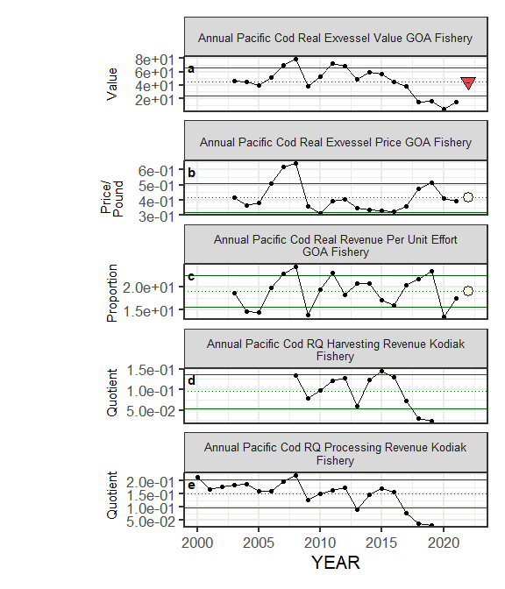

#### Figure 2.1.2b. Selected socioeconomic indicators for GOA Pacific cod with time series ranging from 1977 – present. Upper and lower solid green horizontal lines represent 1 standard deviation of the time series mean. Dotted green horizontal line is the mean of the time series. A symbol appears when current year data are available and follows the traffic light status table designations (triangle direction represents if above or below 1 standard deviation of the time series mean, color only designates above (blue) or below (red) one standard deviation of the time series mean, no implied relationship with the stock).

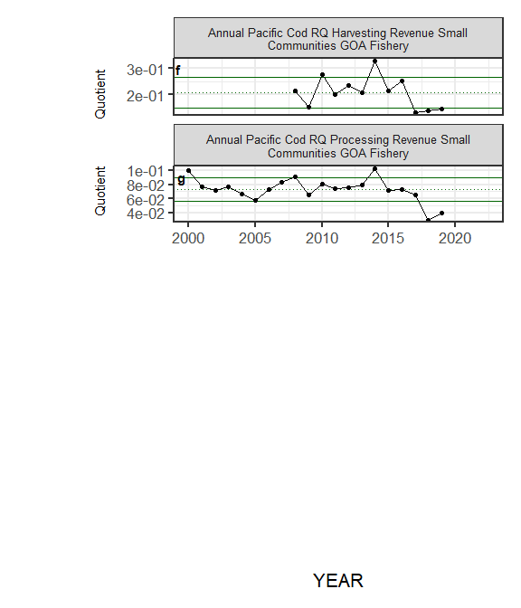

Figure 2.1.2b (cont.). Selected socioeconomic indicators for GOA Pacific cod with time series ranging from 1977 – present. Upper and lower solid green horizontal lines represent 1 standard deviation of the time series mean. Dotted green horizontal line is the mean of the time series. A symbol appears when current year data are available and follows the traffic light status table designations (triangle direction represents if above or below 1 standard deviation of the time series mean, color only designates above (blue) or below (red) one standard deviation of the time series mean, no implied relationship with the stock).

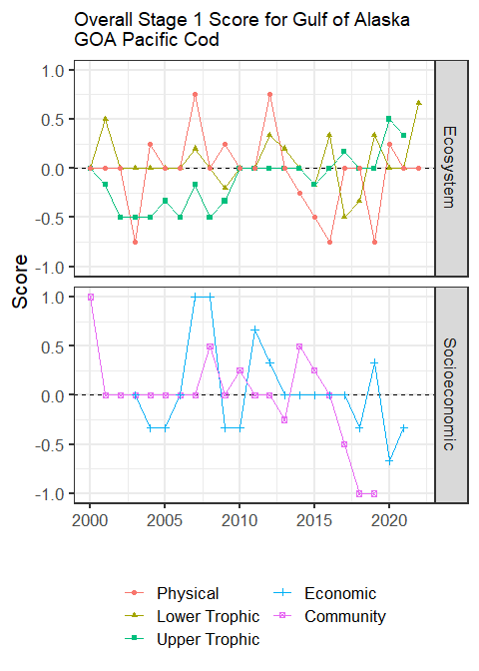

#### Figure 2.1.3: Simple summary traffic light score by category for ecosystem and socioeconomic indicators from 2000 to present.

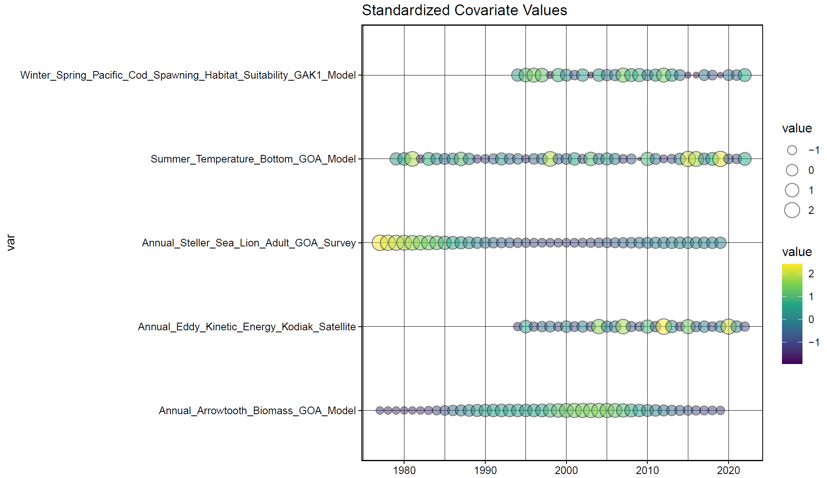

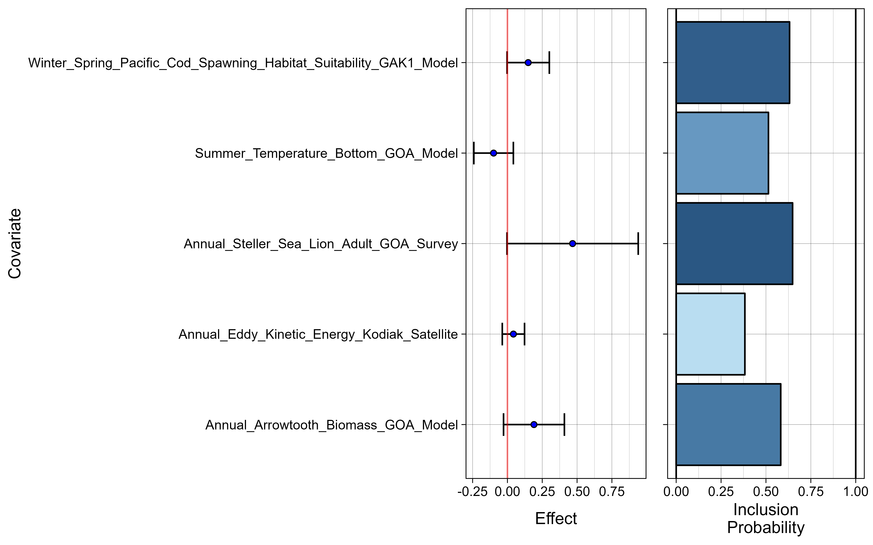

#### Figure 2.1.4: Bayesian adaptive sampling output showing (top graph) standardized covariates and (bottom graph) the mean relationship and uncertainty (95% confidence intervals) with log GOA Pacific cod recruitment, in each estimated effect (left bottom graph), and marginal inclusion probabilities (right bottom graph) for each predictor variable of the subsetted covariate set.